3B Measurement – Lesson 6
Applications of Perimeter, Area and Volume.
Volume of Right Cylinders & Prisms.

Name: _________________

- Which formula would you use? Join the dots on the left [solid] to the dots on the right [formulas].

Solid Formulas

Cube   ¹/₃ L³

Cylinder   ¹/₃ L x B x H

Square Pyramid   L³

Cone   π r² h

Rectangular Prism   ¹/₃ π r² h

Rectangular Pyramid   L x B x H

- What is the difference between a prism and pyramid?.

  - Draw a Square Prism. b) Draw a Square Pyramid.

- Write down the formula and find the volume of the following prisms.

  - Cube
ii) Cube of side 5 cm.

3m
3m
3m
  - Rectangular Prism
ii) Sides of 10 cm, 12 cm and 5 cm.

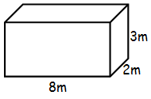

  - Cylinder

    - ii) Radius of 5 cm and height of 7 cm.
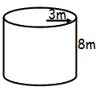

- Find the volume of the following pyramids.

  - Square Pyramid
ii) Square of side 5 cm and height 6 cm.

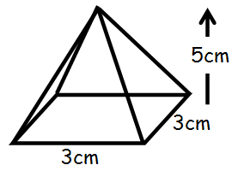

  - Rectangular Pyramid
ii) Sides 10 cm, 12 cm and height 5 cm.

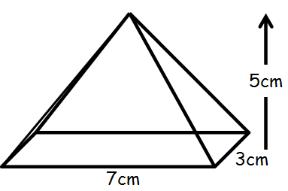

  - Cylinder
ii) Radius of 5 cm and height of 7 cm.

